21BDS0340

Abhinav Dinesh Srivatsa

Database Management Systems Lab

Exercise – IV

1. How many different departments are there in the ‘employee’ table

Command:

select distinct dept from employee_bds0340;

Output:

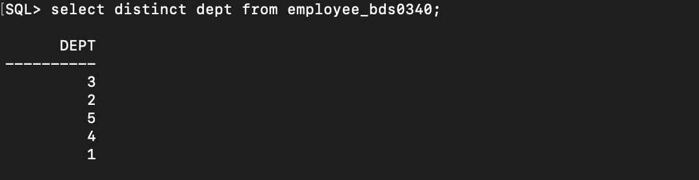

1. For each department display the minimum and maximum salaries

Command:

select dept, min(salary), max(salary) from employee_bds0340 group by dept;

Output:

1. Print the average annual salary

Command:

select avg(salary) from employee_bds0340;

Output:

1. Count the number of employees over age 30

Command:

select count(*) from employee_bds0340 where floor(months_between(sysdate, bday) / 12) >= 30;

Output:

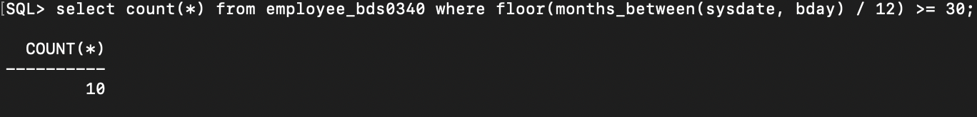

1. Print the department name and average salary of each department

Command:

select d.name, avg(e.salary) from employee_bds0340 e join department_bds0340 d on e.dept = d.num group by d.name;

Output:

1. Display the department name which contains more than 30 employees

Command:

select d.name from employee_bds0340 e join department_bds0340 d on e.dept = d.num group by d.name having count(*) >= 30;

Output:

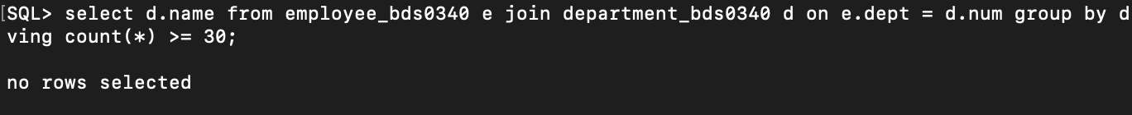

1. Calculate the average salary of employees by department and age

Command:

select d.name, floor(months_between(sysdate, e.bday) / 12) as age, avg(e.salary) from employee_bds0340 e join department_bds0340 d on e.dept = d.num group by d.name, floor(months_between(sysdate, e.bday) / 12);

Output:

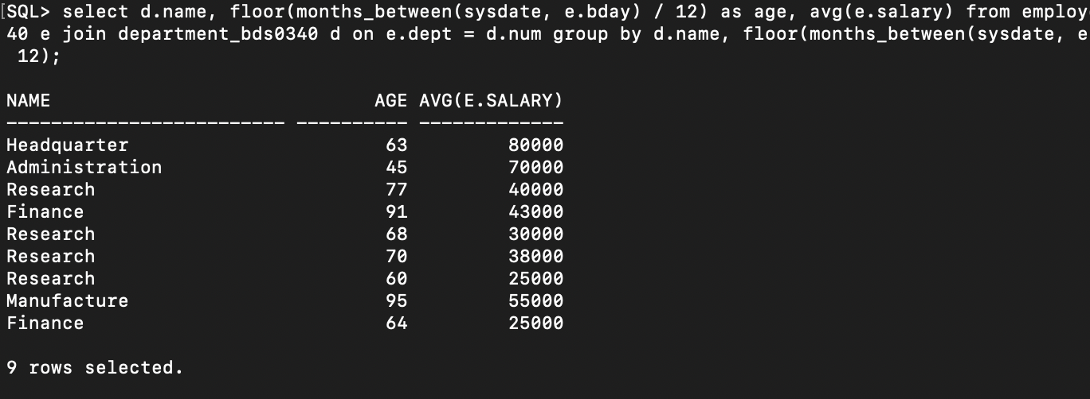

1. Count separately the number the number of employees in the research and finance department

Command:

select d.name, count(*) from employee_bds0340 e join department_bds0340 d on e.dept = d.num where d.name in ('Research', 'Finance') group by d.name;

Output:

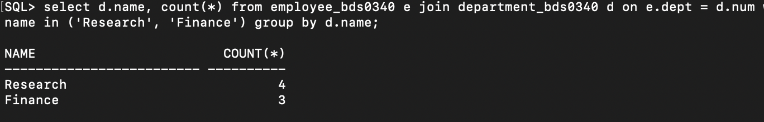

1. List out all the employees based on seniority

Command:

select l_name, m_name, l_name from employee_bds0340 order by months_between(sysdate, bday);

Output:

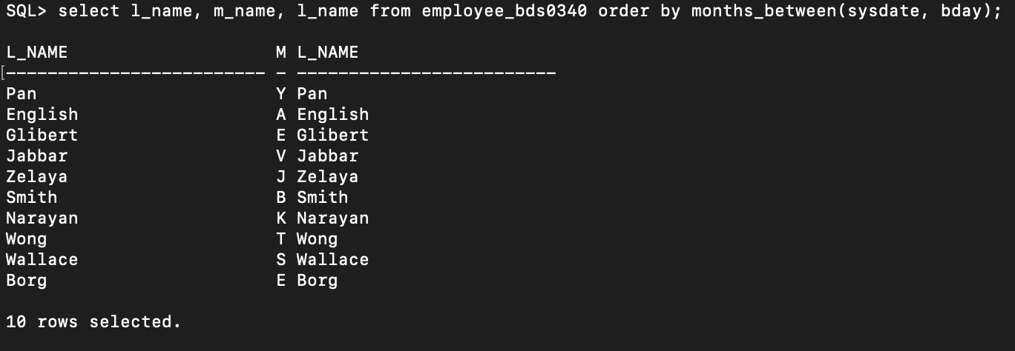

1. List out all the employees who works in manufacturing department and group by first name

Command:

select f_name from employee_bds0340 where dept = (select num from department_bds0340 where name = 'Manufacture') order by f_name;

Output:

